**Receive the Holy Spirit**

**Reading:** From Acts chapter 2

When the day of Pentecost came, all the believers gathered in one place. Suddenly a sound came from heaven. It was like a strong wind blowing. It filled the whole house where they were sitting. They saw something that looked like fire in the shape of tongues. The flames separated and came to rest on each of them. All of them were filled with the Holy Spirit. They began to speak in languages they had not known before. The Spirit gave them the ability to do this.

Godly Jews from every country in the world were staying in Jerusalem. A crowd came together when they heard the sound. They were bewildered because each of them heard their own language being spoken. The crowd was really amazed. “We hear all these people speaking about God’s wonders in our own languages! What does this mean?”

**Thought about the reading**

Pentecost was a Jewish celebration like Harvest Festival, when they thanked God for the food growing in the fields. Today Pentecost is the day when followers of Jesus remember how the Holy Spirit came.

Before he went back to heaven, Jesus promised to send the Holy Spirit to help his followers. At Pentecost he kept his promise. Two amazing things happened! All his friends started talking in different languages which they had not learnt! Then Peter stood up and told a big crowd all about Jesus. Lots of people decided to follow Jesus. When Jesus died on the cross, Peter was very frightened. Now he was not frightened any more. The Holy Spirit helped him.

Jesus promised to give the Holy Spirit to us too. The Holy Spirit helps us to live the way that Jesus wants us to. He helps us to love other people. He helps us to pray. He helps us to tell other what God has done for us.

**Prayer**

Lord Jesus, thank you that you sent the Holy Spirit to your friends. Please send him to help us.

Holy Spirit, please come and live in us. Please help us to live the way that Jesus wants us to.

Amen

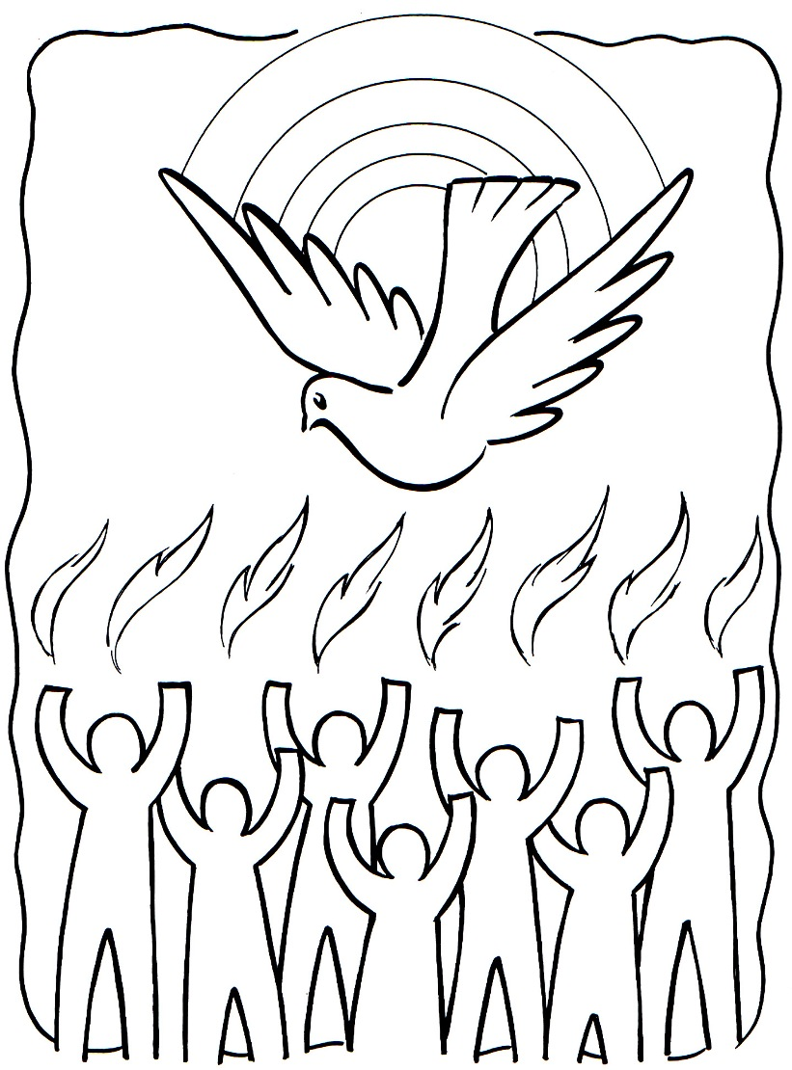

**Cambridge Causeway**

Summer 2025

Bible Study notes

**How Jesus wants me to live**

**4. Receive the Holy Spirit**

By Chrissy Cole